STRAWSOFBAMBOO
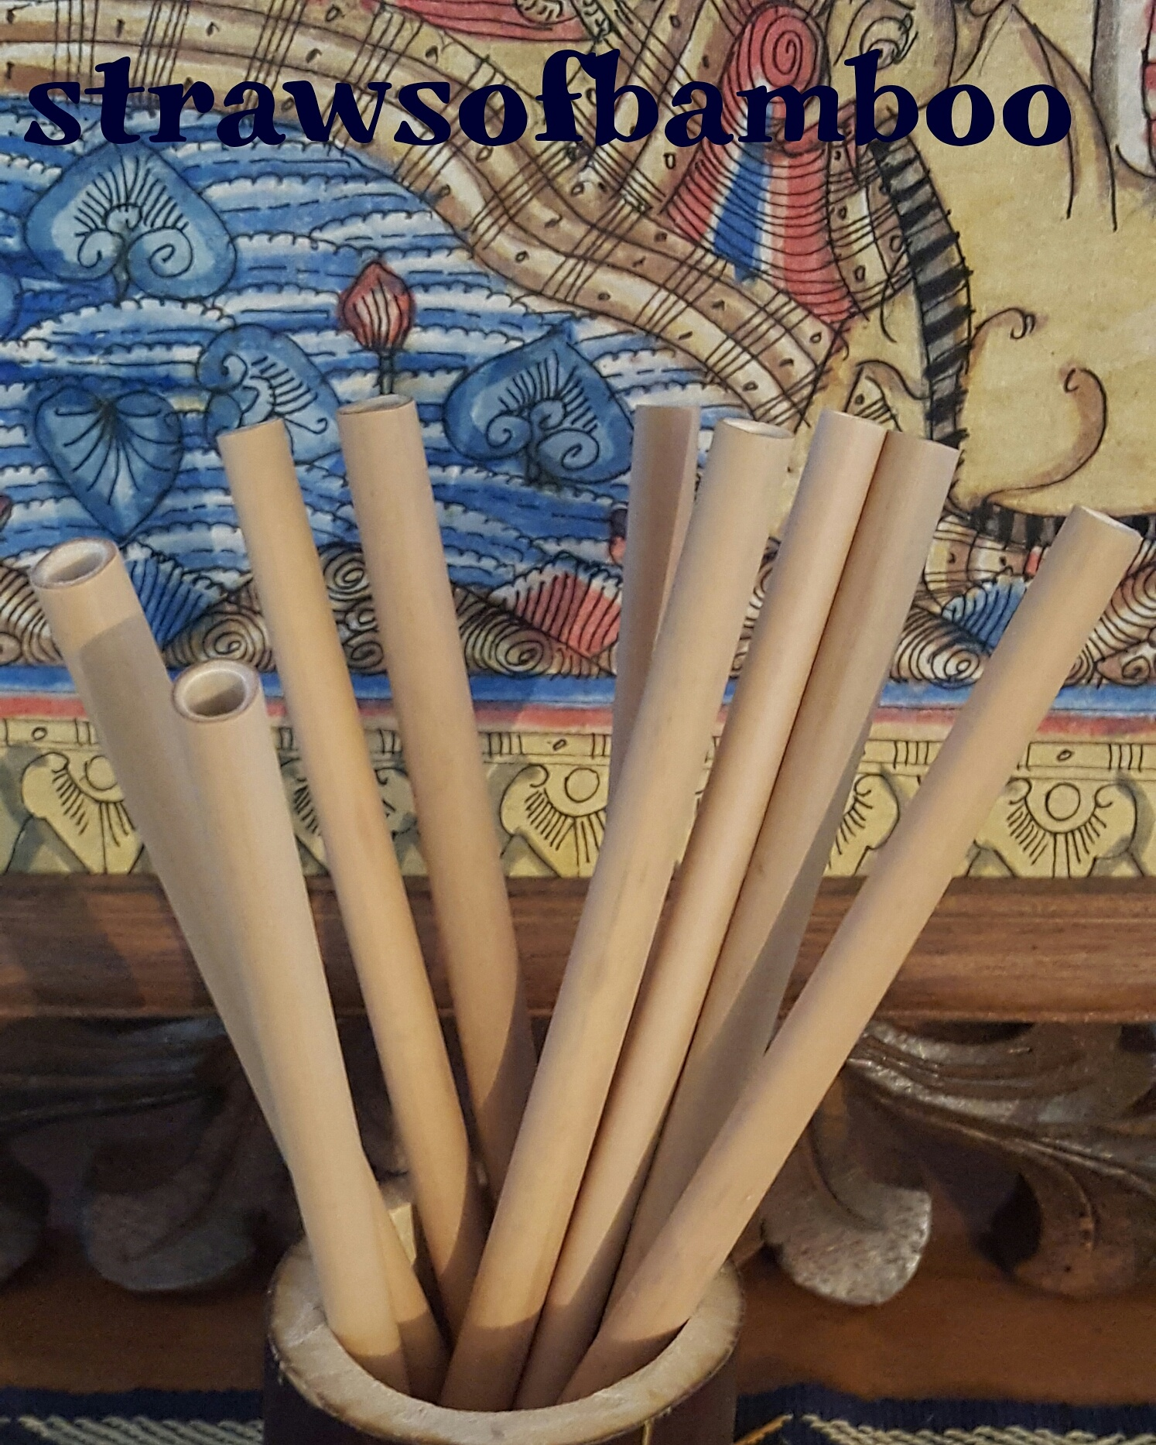

STRAWS OF BAMBOO
Hi, my name is Kym Clasby. I have decided to promote and sell bamboo drinking straws, bamboo straw cleaning brushes and bamboo straw storage pouches. My passion is to help remove wasteful plastic from our society. So, I would like you to consider introducing bamboo drinking straws as a retail item in your store. Or to be used in place of single use straws, both in house or with takeaway juices and smoothies. You could be part of the movement to reduce plastic waste in Australia. These straws of bamboo are: Natural, Recyclable, Bio-Degradable and are Chemical Free. Bamboo also has natural Anti-Microbial properties. They are fair trade and totally sustainable. regards Kym Clasby
200mm straws: $1.20 each. Suggested retail price approximately $3.00 each.
150mm straws: $1.00 each. Suggested retail price approximately $2.80 each
bamboo straw cleaner brush: $1.00 each. Suggested retail price approximately $2.00 each.
bamboo drinking straw pouch: $1.00 each. Suggested retail price approximately $2.00.
Black bamboo display cup: $5.00 each.
Bulk purchase prices available.
Plus freight as needed.
Phone 0429 111 180 FB and Instagram @strawsofbamboo kymclasby@westnet.com.au

